API Security Risk Analysis

Cyber Security Task 3 (2026)
API Security Risk Analysis

About the Task:-
APIs (Application Programming Interfaces) are used by applications to exchange data.
If APIs are not properly secured, attackers can misuse them to access sensitive data.
This task focuses on understanding API security risks and analyzing a public API in a safe and legal way.

Objective:-
The objectives of this task are:
- To understand basic API concepts
- To analyze a public demo API
- To identify possible security risks
- To suggest security improvements
- To learn safe API testing practices
Tools Used:-
- Postman (API testing tool)
- Public Demo API
- Web Browser
- Canva (for report creation)
Postman was used to send requests and observe API responses.

API Tested:-
API Name: JSONPlaceholder / ReqRes
API Type: Public Demo API
Endpoint Tested:
https://jsonplaceholder.typicode.com/users
(or)
https://reqres.in/api/users
These APIs are created only for learning and testing purposes.

Testing Process:-
- The API endpoint was opened in Postman
- Request method used: GET
- No authentication or token was provided
- The request was sent using Postman

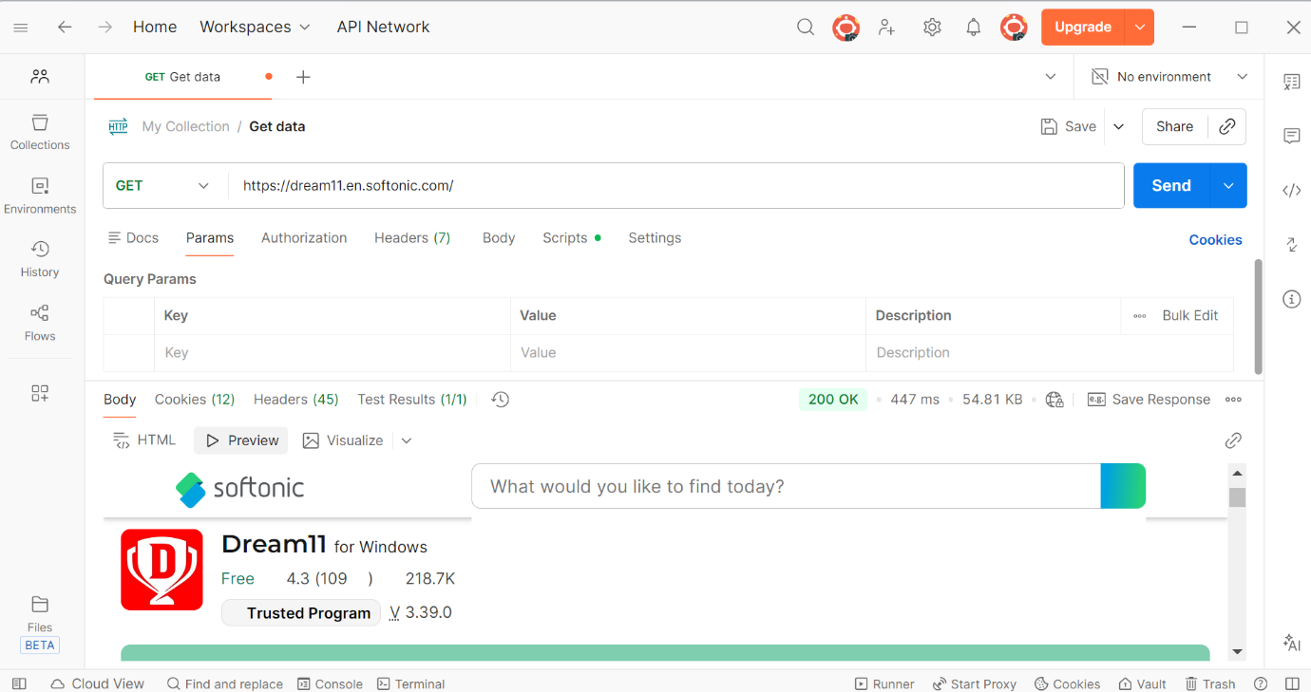
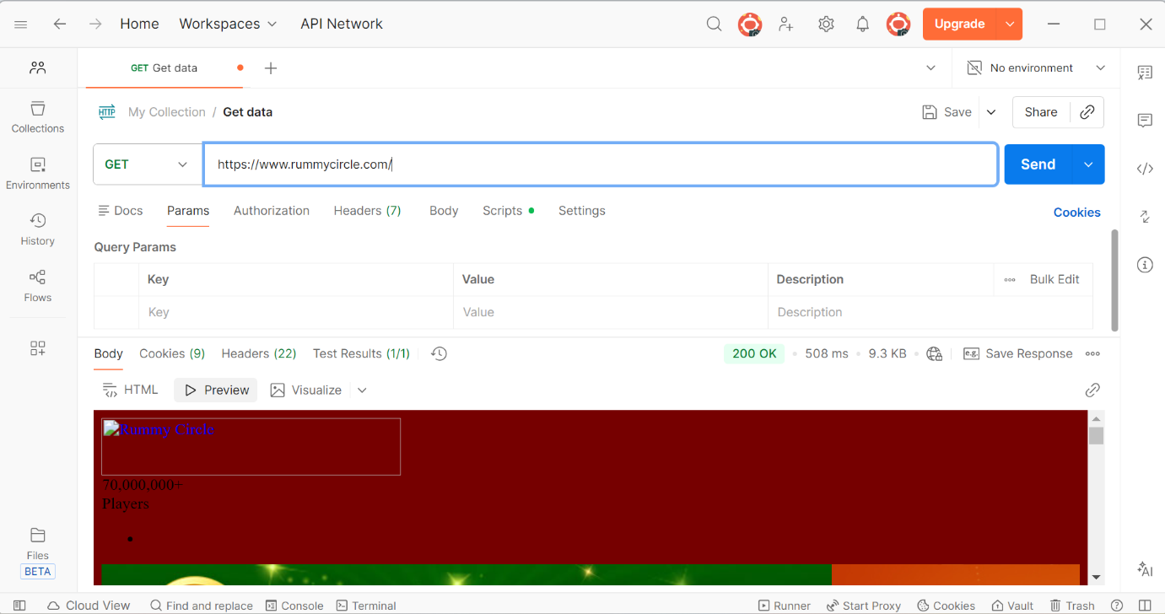

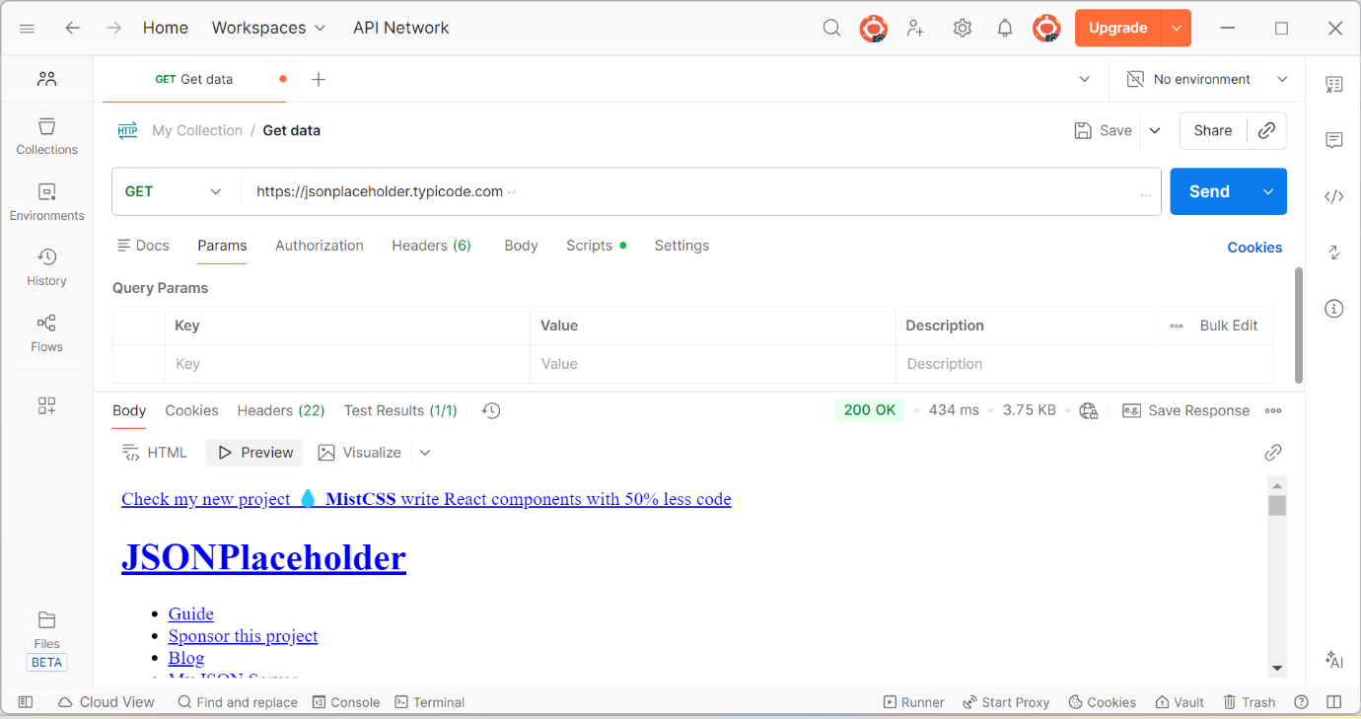

Identified API Security Risks:-
- No authentication required
- No authorization controls
- Open access to user data
- Possible data exposure risk
These issues can lead to misuse if the API is deployed in a real system.
Security Recommendations:-
Implement authentication (API keys or tokens)
- Apply authorization and access control
- Use rate limiting
- Monitor API usage
- Protect sensitive data
Proper API security helps prevent unauthorized access.
Conclusion:-
API security is essential to protect user data and system integrity.
This task helped in understanding common API security risks and how they can be reduced using proper security measures.

